

Business Requirements
InsCore – Producer Commission Screen (Intake UI) – Level 2

Document Version Control
Version | Release Date | Revision Description | Author(s)
0.1 | 14-Jul-2025 | Baseline | Rajesh Kumar

Review
Version | Name of Reviewer | Designation | Signature & Date
0.1 | Ronan T Whyte
0.1 | JJ Hayes

Approval
Version | Name of Approver | Designation | Signature & Date  Email Approval
0.1 | Igor Garcia <Igor.Garcia@aig.com> |  | 28/11/2025
0.1 | Igor Vieira <Igor.Vieira@aig.com>
0.1 | Eliana Christoforou <Eliana.Christoforou@AIG.com>

Table of Contents

Table of Contents 3
1.Introduction 4
2.Purpose 4
3.Scope 4
4.Assumptions 5
5.Business Requirements 5
6.Rules 9
7.Non-Functional Requirements 9
8.Appendix 10

1.Introduction
Producer commission is the payment made to an insurance broker for selling the insurance policies. This commission is typically a percentage of the insurance premium paid by the policyholder or an amount agreed between the insurance company and the broker. The commission is paid to the broker when the policy was initially sold to the insured and subsequent premium payments for renewal/endorsement. The Producer commissions can be attached at Policy/Producer/Section/Risk/Coverage level. There are 2 types of Producers – Lead Producer (1st Producer) and Follow Producer (2nd Producer). Lead (1st) Producer is always there on a Policy whereas Follow (2nd) Producer might or might not exist on all the policies. Producer Commission is calculated for New Business, MTA, Renewal and Cancellation transactions. Producer commission details received from Policy Contract can be overridden from UI.
Note: There is a separate BRD to capture the Producer Information on the UI Intake Screen - InsCore Producer Information_V0.1.docx

2.Purpose
The Purpose of this Business Requirements Document (BRD) is to lay down the future state requirements for capturing the producer commission and validations on the Intake UI as part of the TO-BE process for policy bookings in Iberia region (Portugal and Spain)
This comes as a part of the Inscore solution.
Link for BRD for End to End Booking Transaction Flow - InsCore Booking Transactions Flow_V0.1.docx

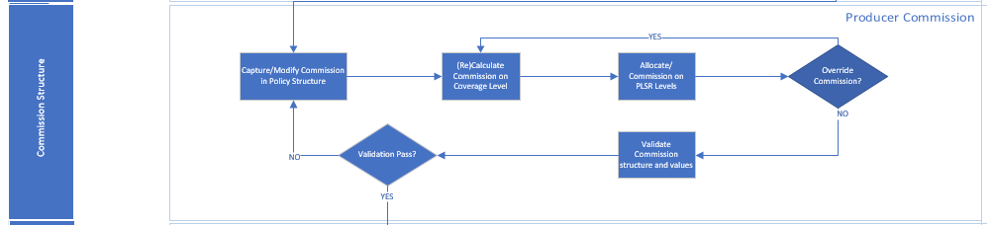

3.Scope
Transaction type – New Business
Producer Commission validations & calculation are in scope for this BRD
This document covers the UI screen and the business logic for populating the following producer-level data for a New Business policy transaction:
- Validation of Producer Commission Attributes (Fields) entered on Intake Screen
- UI Mock-ups for Producer Commission Screen
- Saving/Retrieving Producer Commission details into Policy Object Model
- Calculations and Validations of the Producer Commission on Intake Screen
Out of Scope: The detailed technical implementation and the full end-to-end booking flow are covered in other documents. Other transactions like MTA, Renewal, Cancellation & reinstatement and will be added to this BRD in upcoming versions post Pilot. API requirements will be added to this BRD in upcoming versions post Pilot.

4.Assumptions
Assumption Id | Description
A01 | There will be no default setup for the producer commissions in Inscore. The upstream systems will be sharing the producer commission percentage or amount which can be at policy/producer, location, section, risk and coverage level. If the upstream systems share commission percentage, then the commission amount will be derived in InsCore from the percentage value received as Producer Commission value
A02 | The mock-ups referenced in the BRD are subject to stakeholder approval and wireframing. This BRD has been designed based on the currently available mock-ups and any changes arising from subsequent modifications will be incorporated.

5.Business Requirements
COM_BR01: New Business Commission – (Applicable for API intake and UI intake)
For New Business transaction, commission calculation happens at P/L/S/R/C levels as per Rules COM_R001/ COM_R002/ COM_R003 (as applicable). Premium used in this calculation will be the New Business premium.
COM_BR02: Commission Inheritance – (Applicable for API intake and UI intake)
If Commission Percentage is received through API or entered in UI at a higher level, then all the corresponding lower levels will inherit the same commission percentage as per Rule COM_R005.
If Commission Amount is received through API or entered in UI at Producer level, then corresponding Commission percentage will be calculated as per Rule COM_R006, and all the corresponding lower levels will inherit the same commission percentage as per Rule COM_R005.
Refer Example 1 and Example 3 from ‘Detailed Examples’ tab present in the below spreadsheet
Producer Commission Examples.xlsx
COM_BR03: Commission Override – (Applicable only for UI intake)
If Commission Percentage is overridden/ entered in UI at a particular level (P/L/S/R/C level) then the overridden/entered percentage value is taken for commission calculation. Once the commission percentage is overridden/entered at a particular level then the corresponding lower levels will inherit the same commission percentage as per Rule COM_R005 (Refer Rules Tab)
Refer Example 3 from ‘Detailed Examples’ tab present in the below spreadsheet
Producer Commission Examples.xlsx
If Commission Amount is overridden/ entered in UI at a particular level (P/L/S/R/C level) then the overridden/entered percentage value is taken for commission calculation. Once the commission percentage is overridden/entered at a particular level then the corresponding lower levels will inherit the same commission percentage as per Rule COM_R005 (Refer Rules Tab)
Refer Example 2 from ‘Detailed Examples’ tab present in the below spreadsheet
Producer Commission Examples.xlsx
COM_BR04: Commission Roll Up – (Applicable for API intake and UI intake)
Commission Amount calculated at the lower levels will be rolled up to corresponding higher level as per Rule R004. Once the commission amounts are rolled up then the corresponding Commission Percentage is calculated at each level as per Rule COM_R006
Note: Commission Percentage calculated because of roll up of commission amount will not be inherited by lower levels
Refer Example 3 from ‘Detailed Examples’ tab present in the below spreadsheet
Producer Commission Examples.xlsx
COM_BR05: Lead (1st) and Follow (2nd) Producer Commission – (Applicable for API intake and UI intake)
When only two inputs are given as commission percentage for 1st and 2nd producer then the same commission will be inherited at the Location, Section, Risk and Coverage levels
Refer Example 1 from ‘Detailed Examples’ tab present in the below spreadsheet
Producer Commission Examples.xlsx
COM_BR06: Commission value changed to a flat value – (Applicable for UI intake)
When the commission value is updated to a flat value then its corresponding Commission percentage is calculated and rolled up accordingly as per rule COM_R004
Refer Example 2 from ‘Detailed Examples’ tab present in the below spreadsheet
Producer Commission Examples.xlsx
COM_BR07: Commission calculation when location is specialised at Producer level – (Applicable for UI intake)
When the location is specialised and is present at 1st and 2nd Producer level then the commission percentage is applied at 1st level and is also applied for 2nd producer level.
Refer Example 4 from ‘Detailed Examples’ tab present in the below spreadsheet
Producer Commission Examples.xlsx
COM_BR08: Commission calculation in different currencies – (Applicable for UI intake)
There should be ability in the system to calculate the commission in a currency different from the Base currency.
Refer Example 7 from ‘Detailed Examples’ tab present in the below spreadsheet
Producer Commission Examples.xlsx
COM_BR09: Renewal Commission – (Applicable for API intake and UI intake)
Renewal transaction commission calculations happen at P/L/S/R/C levels as per Rules COM_R001/COM_R002/COM_R003 (as applicable). Premium used in this calculation will be the Renewal Premium.
COM_BR02, COM_BR03, COM_BR04 are applicable for Renewal transaction
COM_BR10: MTA Commission – (Applicable for API intake and UI intake)

MTA transaction commission calculations happen at P/L/S/R/C levels as per Rules COM_R001/COM_R002/COM_R003 (as applicable). Premium used in this calculation will be the Change in Premium due to MTA.

COM_BR02, COM_BR03, COM_BR04 are applicable for MTA transaction

COM_BR11: Cancellation Commission – (Applicable for API intake and UI intake)
Cancellation transaction commission calculations happen at P/L/S/R/C levels as per Rules COM_R001/ COM_R002/ COM_R003 (as applicable). Premium used in this calculation will be the Change in Premium due to Cancellation.
COM_BR02, COM_BR03, COM_BR04 are applicable for Cancellation transaction

6.General Parameters required for Producer Commission
Data intake happens via API or entered through UI. Below are the various producer commission related attributes expected as part of the policy contract (API) or manually entered through UI as shown below. If the commission is entered through UI (either for failed API intake or if user wants to override the existing values), the data is entered in the following screen on UI for different transactions
- Producer Code: Producer code to which the commission applies
- Producer Commission Basis Code: Code that denotes basis of a Producer commission calculation. This code shall be provided for each level on which the commission value is provided. This code is used in Rules R001, R002, R003 in the Rules section
  - 01-Amount - Commission is received directly as an amount and not as a percentage of premium
  - 02-Percent on Premium – For this code, the commission will be a percent of the Premium written Amount
  - 03 – Percent on Premium & Taxes
  - 04-Percent on Fees – For this code, the commission will be a percent of the Fees

Note - Only 02 is used in Iberia

- Producer Commission Type: Defines the type of producer commission – amount (A) or percent (P).
Only Percent (P) is used in Iberia
- Producer Commission Value: Policy/Producer/Location/Section/Risk/Coverage level Commission value either Amount or Percentage). Percentage value will be used to derive Commission Amount
- Premium: Premium (Premium written amount) to be received in Policy Contract to calculate the Commission
Screen Mock-up –
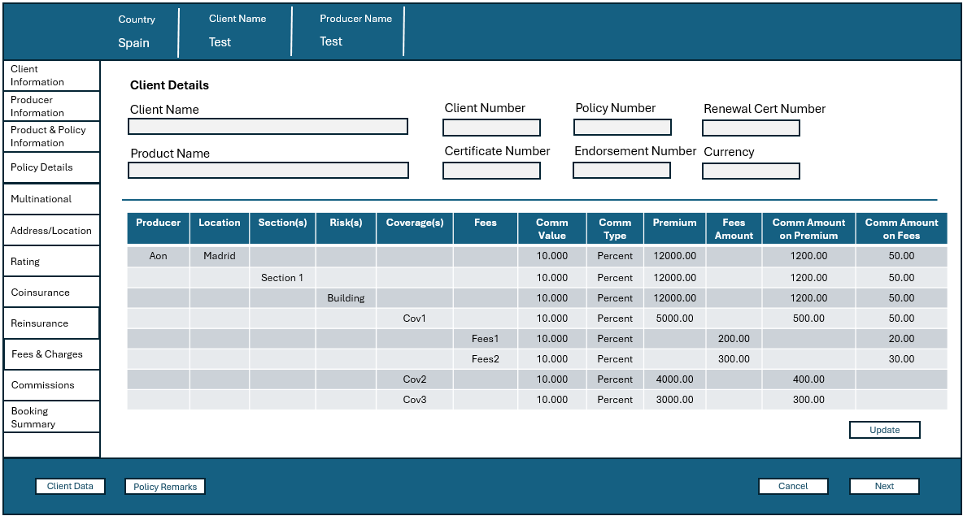

Grid Column | Details | Editable/  Read-only
Producer | Displays Producers. | Non-Editable
Location | Displays Locations. | Non-Editable
Section(s) | Displays Sections. | Non-Editable
Risk(s) | Displays Risks. | Non-Editable
Coverage(s) | Displays Coverages. | Non-Editable
Fees | Displays Fees.  Displayed if Producer Commission Basis Code is ‘04’ | Conditional Non-Editable
Comm Value | Displays the Commission Value as Percent value or Amount value. | Editable Field
Comm Type | Displays as ‘Percent’ if Producer Commission Basis Code is ‘02’ or ‘04 and as ‘Amount’ if the code is ‘01’. | Non-Editable
Premium (PWA) | Displays the Premium Written Amount at P/L/S/R/C level. | Non-Editable
Fees Amount | Displays the Fees Amount at Coverage level.  Displayed if Producer Commission Basis Code is ‘04’ | Conditional  Non-Editable
Comm Amount on Premium | Displays the Commission Amount on Premium at P/L/S/R/C level. | Editable
Comm Amount on Fees | Displays the Commission Amount on Fees at Coverage level.  Displayed if Producer Commission Basis Code is ‘04’ | Conditional Editable

The Commissions which are calculated at different levels (Policy, Location, Section, Risk and Coverage) is stored in Policy Object Model (POM).
Refer the POM structure present at the following path
InsureSync_POM_Entity Mapping_v2.0.xlsx
POM Specification Tab: Under “Commission” entity, the following data elements hold the values corresponding to Commission Calculation
- comm_basis_cd – Holds the commission basis code (01/02/03/04)
- comm_attch_lvl_cd – Displays which level the calculated commission needs to be displayed (PLSRC)
- prdr_comm_type – Percent or Amount
- prdr_comm_value – Value that defines the Producer Commission Type
- prdr_comm_amt – Calculated Producer Commission amount at PLSRC levels.

7.Rules
Rule Id | Rule Description
COM_R001 | If Producer Commission Basis Code = 01 then Commission Amount is received in Policy Contract instead of Commission percentage  Formula: N/A  Note: Currently used only in Malta and not other countries
COM_R002 | If Producer Commission Basis Code = 02 then the Commission Amount is calculated as per the below formula  Formula: Commission Amount = Premium Written Amount * (Commission percentage /100)  Note: For Iberia region only this Commission Basis Code is used and not the other codes
COM_R003 | If Producer Commission Basis Code = 04 then the Commission Amount is calculated as per the below formula  Formula: Commission Amount = Fees Amount * (Commission percentage /100).
COM_R004 | Coverage level commission amounts should sum up to corresponding Risk level  Risk level commission amounts should sum up to corresponding Section level  Section level commission amounts should sum up to corresponding Location level  Location level commission amounts should sum up to corresponding Producer level
COM_R005 | If commission percentage is received in API intake or entered in UI at Producer level then the same percentage is taken for commission calculation at corresponding location, section, risk and coverage levels  If commission percentage is received in API intake or entered in UI at Location level then the same percentage is taken for commission calculation at corresponding section, risk and coverage levels  If commission percentage is received in API intake or entered in UI at a particular Section level then the same percentage is taken for commission calculation at corresponding risk and coverage levels  If commission percentage is received in API intake or entered in UI at a particular Risk level then the same percentage is taken for commission calculation at corresponding coverage levels  If commission percentage is received in API intake or entered in UI at a particular Coverage level then the same percentage is taken for commission calculation at corresponding Fees levels (if Fees is present on the coverage)
COM_R006 | Commission Percentage = Comm Amount (Premium) * 100 / Premium (at every P/L/S/R/C level)  Commission Percentage = Comm Amount (Fees) * 100 / Premium (at Fees level)
COM_R007 | Commission amount/percent field cannot be blank/empty for 1st producer
COM_R008 | Commission percent field must allow values between 0% and 99.99%.
COM_R009 | Commission amount/ percent field is editable only when the transaction is New Business and Renewal

8.Non-Functional Requirements
- Any new entries or changes to the producer commission percentage and amount should be auditable with proper logs created for the transactions.
- The timestamp of the record addition/changes should also be added in the database table capturing the commission details so that historical changes can be identifiable.

9.Appendix
Producer Commission Basis Code:
Commission basis used in following countries for Transactions >= '2021-01-01'
Countries | comm_basis_cd |  | comm_basis_cd
BE & LUX | 02 |  | 01-AMOUNT
 |  |  | 02-PERCENT ON PREMIUM
UKCOM | <Blank> |  | 03-PERCENT ON PREMIUM AND TAXES
G5 | 02 |  | 04-PERCENT ON FEES
 | 04
FR | 02
 | 04
IT | 02
 | 04
GER & AUS | 02
NED & SWITZ | 02
IE | 02
SA | 02
MA | 02
 | 01
IBERIA | 02

